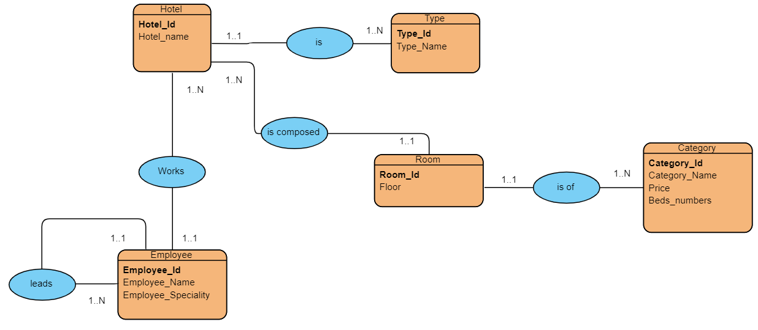

**Hotel** (Hotel_Id, Hotel_name, #type_id)

**Type** (type_id, type_name)

**Employee** (Employee_Id, Employee_Name, Employee_Speciality, #Hotel_Id, #Director_id)

**Room** (Room_id, Floor,#Hotel_Id, #Category_id)

**Category** (Category_Id, Category_Name, Price, Beds_numbers)